**User Manual**

**User Interface Package:**

1). **Movie Search and Listing**: The Screen lists the entire movie and its details including the duration and genre of the movie. This page consists of the navigation menu drawer which will feature Browse by Movie Category, Search movie, Login, Coming soon, Reviews and video gallery. We can share the movie details through social networking via Share icon. User can scroll through tabbed activity of movie to select different movie

Once the user clicks on movie, the application will be directed to next page that will allow user to pick date for booking movie ticket.

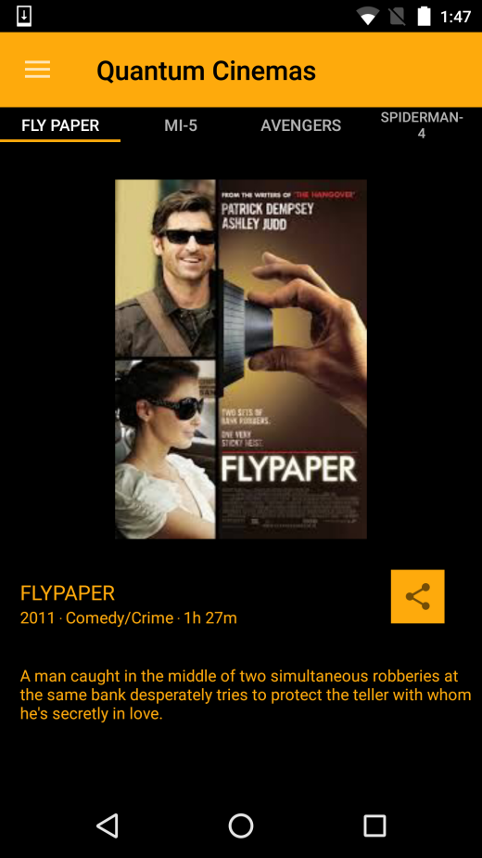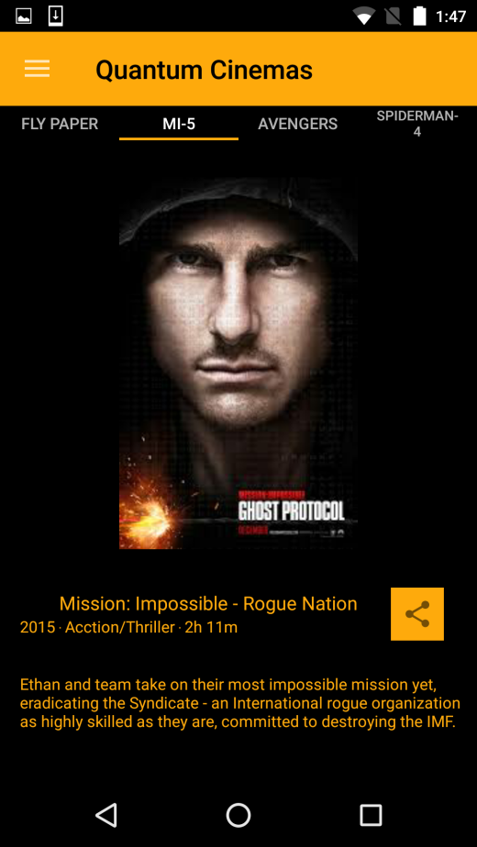

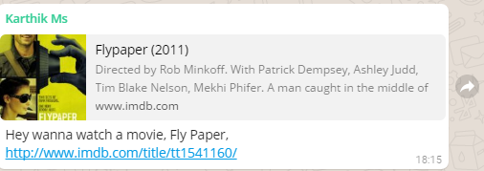

**2) Date Selection:** User can select the date for which he wants to view movie. User cannot select date that is before current date.

On clicking next user will be able to see theatres and timings for movie

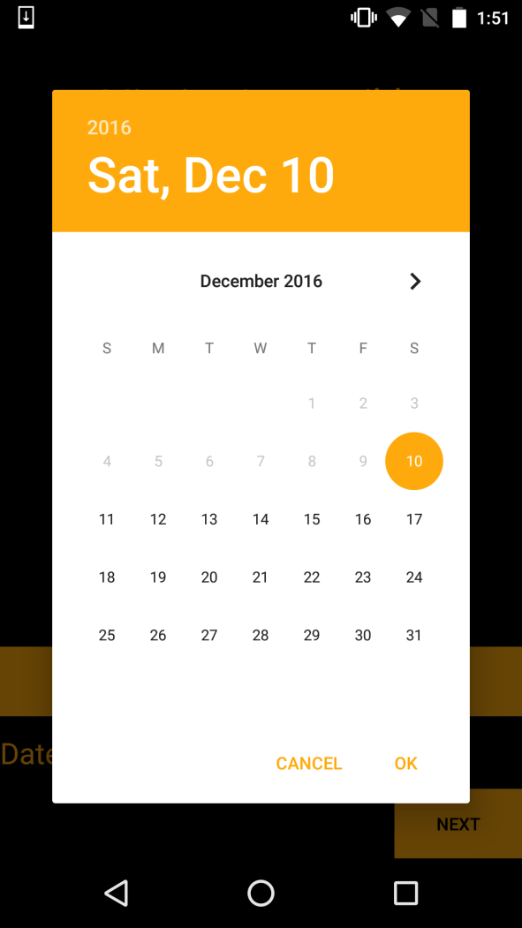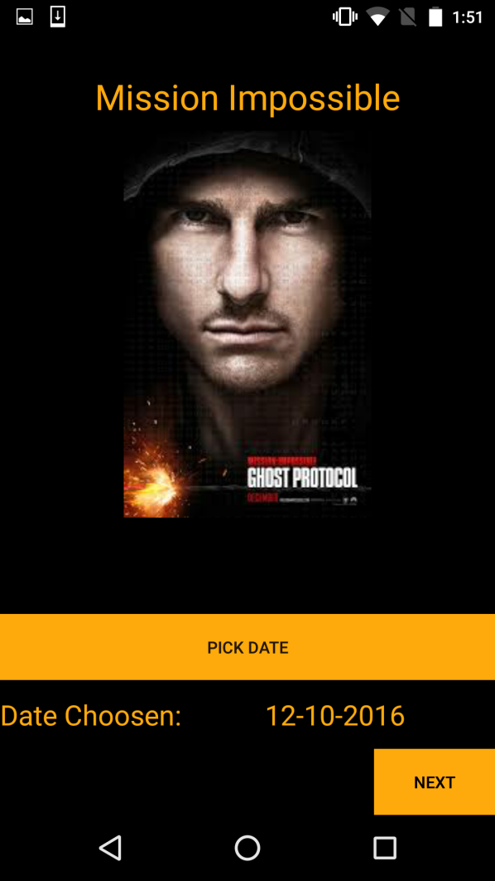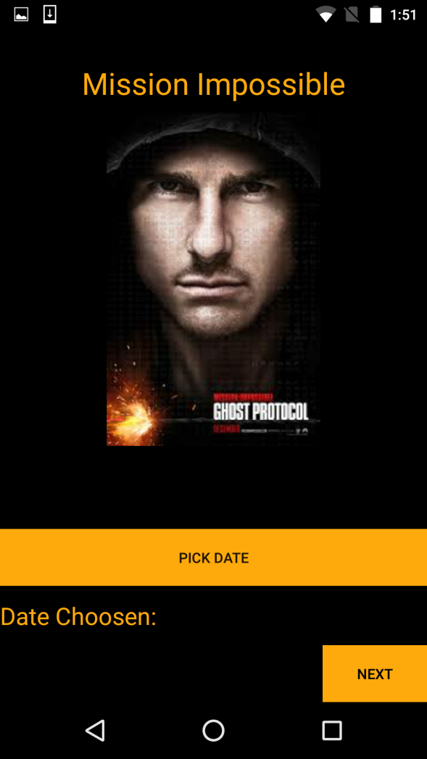

**3) Theatre time Selection:**

This screen will show the timings and theatre available for the movie. When user select theatre and timing of his choice he will be directed to seat booking page

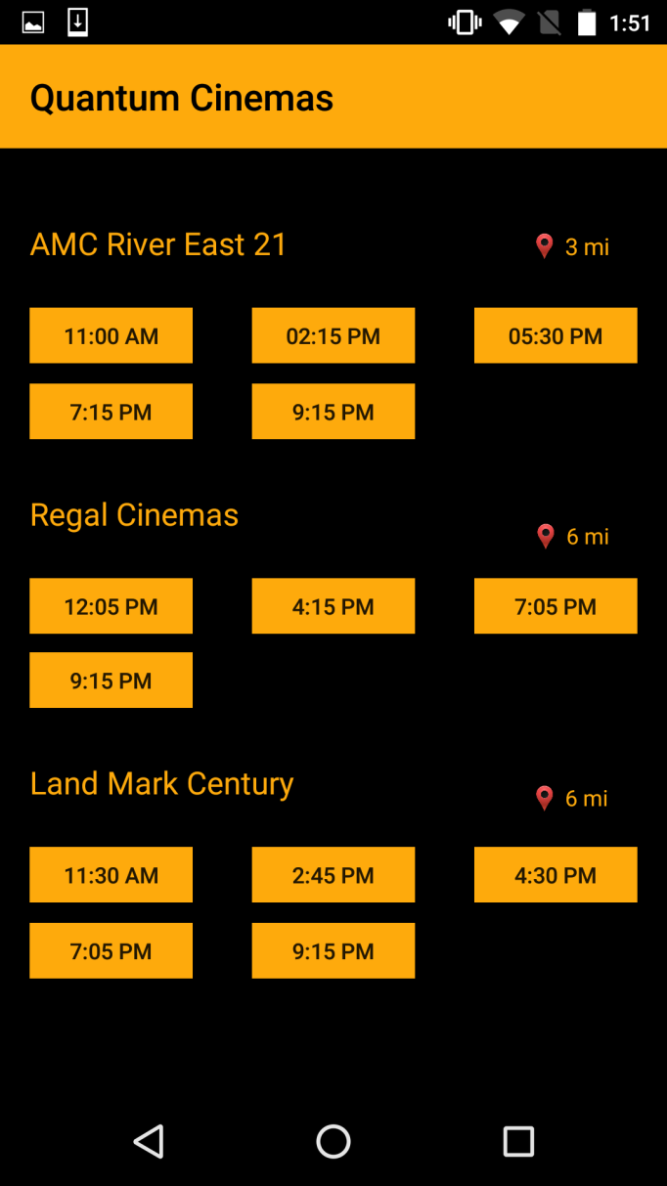

**4) Multiplex Gui Seat Selection**: The user can view the seat location in the theatre and then select the seats of his choice. GUI seat selection helps the user to graphically view the seat locations and easily pick the seat

All the booked seats cannot be selected again. User selected seats will be turned green for that session

Once the user select his seats and clicks on proceed he will be directed to payment processing page

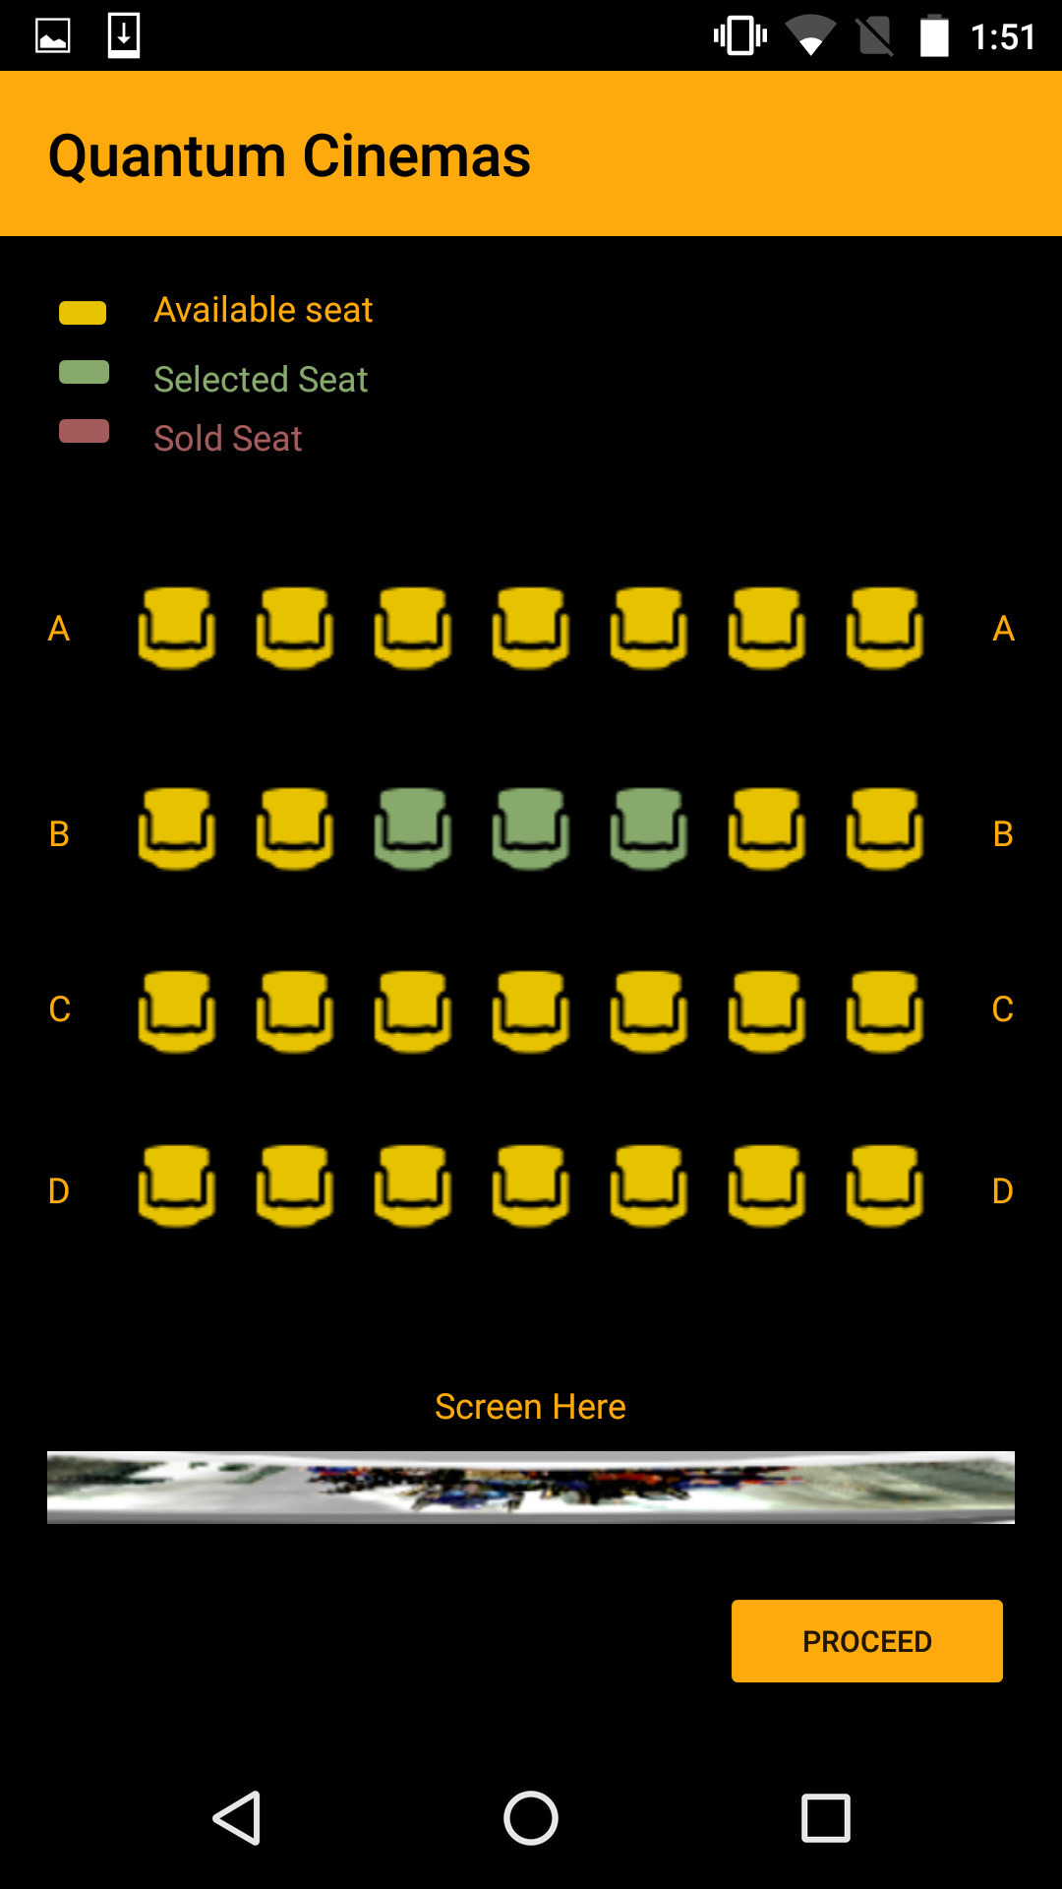

**Payment Processing Page:**

The screen shows the movie details and seats user selected. User has to fill email and phone number details. Once he fills it and clicks proceed a prompt will be displayed that will ask the user to enter their credit card information such as Name on card, Credit Card No, CVV etc.

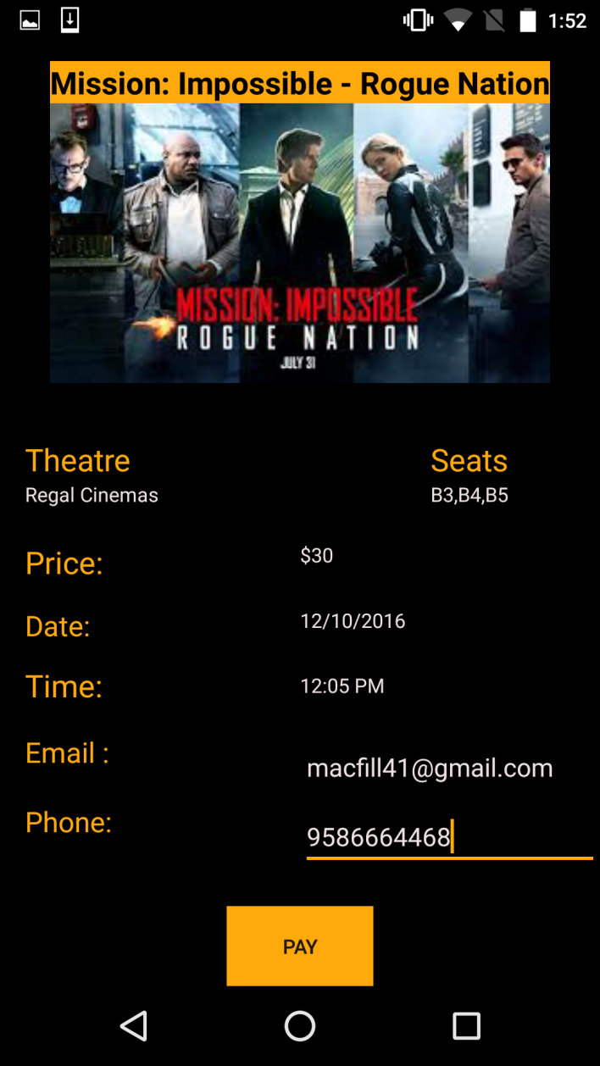

**Payment Processing Dialog:**

This screen allows the user to pay for the movie ticket. The user has to key in his/her credit card details to book the movie ticket.

Once the user fills that information and clicks confirm booking. Order will be processed data will be stored in database and User will be directed to confirmation page.

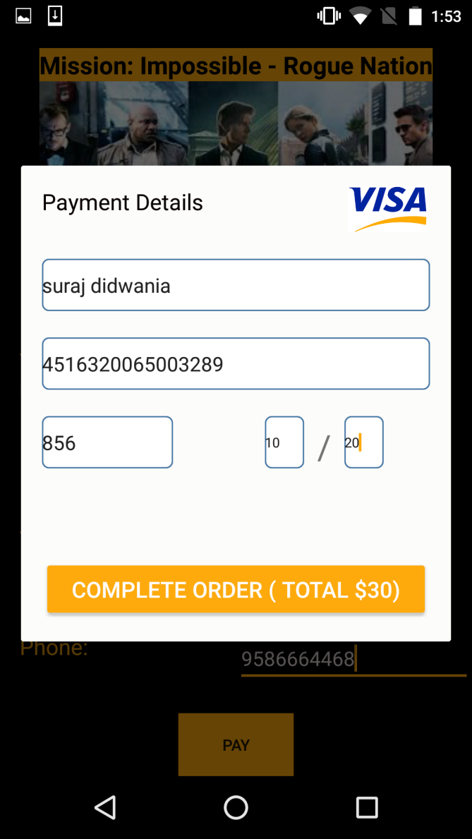

**Movie Confirmation Page:**

The page is final screen of the application where the user gets all the details about the movie and his order summary including order number. The order number will help the user to get the entry into the theatre.

From this activity, user will get sms, email, reminder and Notification about his Movie booking Schedule

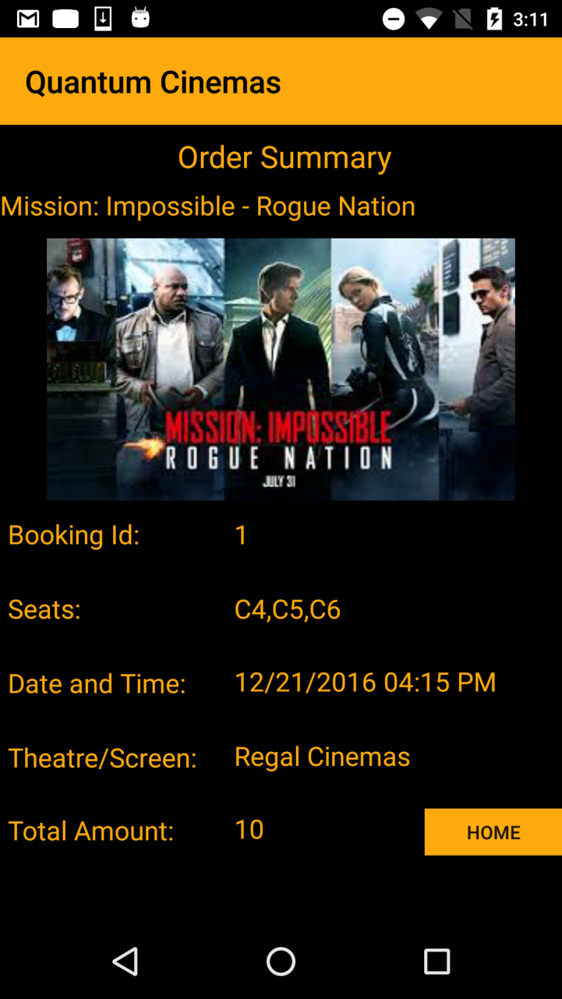 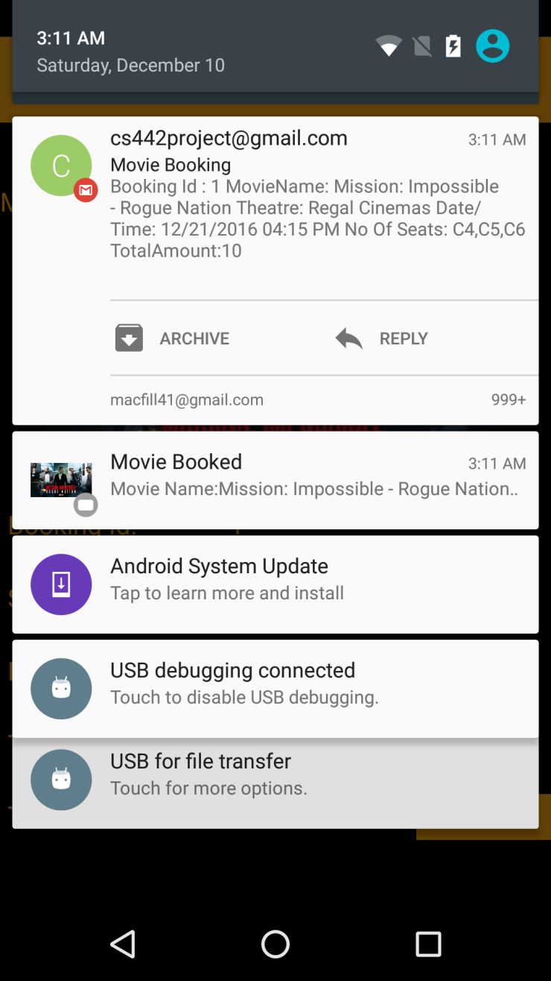

Navigation Menu Drawer:

1. Search Movie:

On clicking this link user will be directed to activity where he can search movie by name

User will get search bar where he can type a letter and movies starting from that letter will be displayed in a list view.

Once the user selects any movie of that list he will directed to respective fragment of that movie

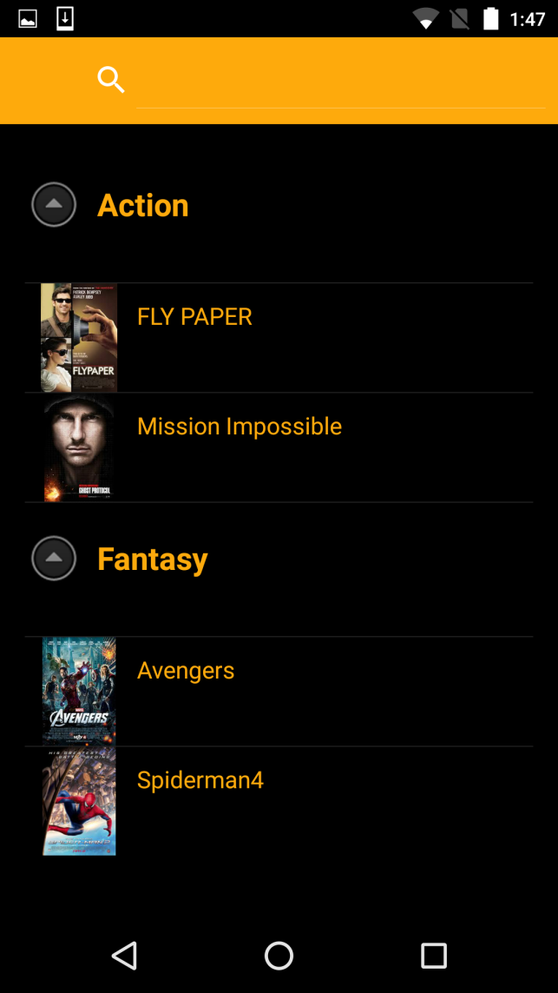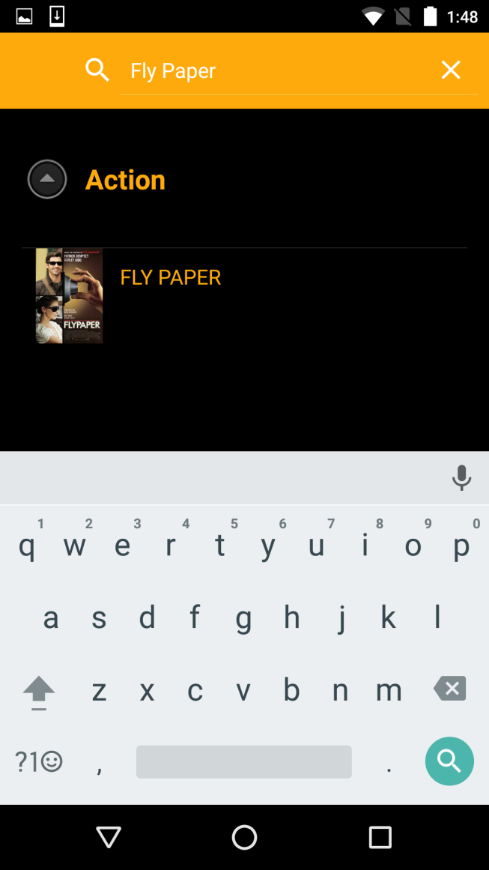

1. Browse Movie by category:

User can select category and he will be directed to that movie fragment of category

1. Gmail Login:

On clicking this link user will be directed to page where he can sign in through Gmail to the application. Sign in is required for seat booking. Without sign in user cannot proceed for seat booking.

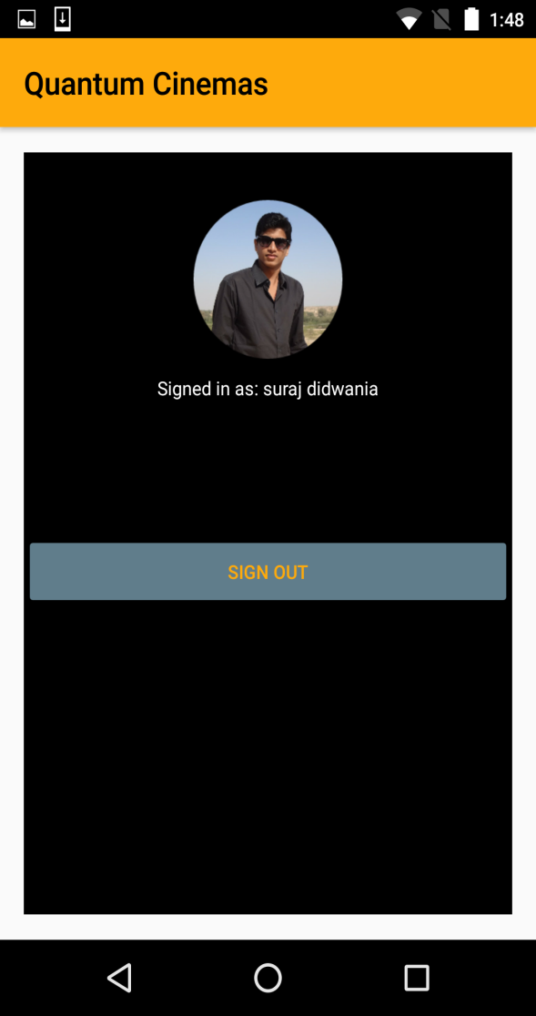

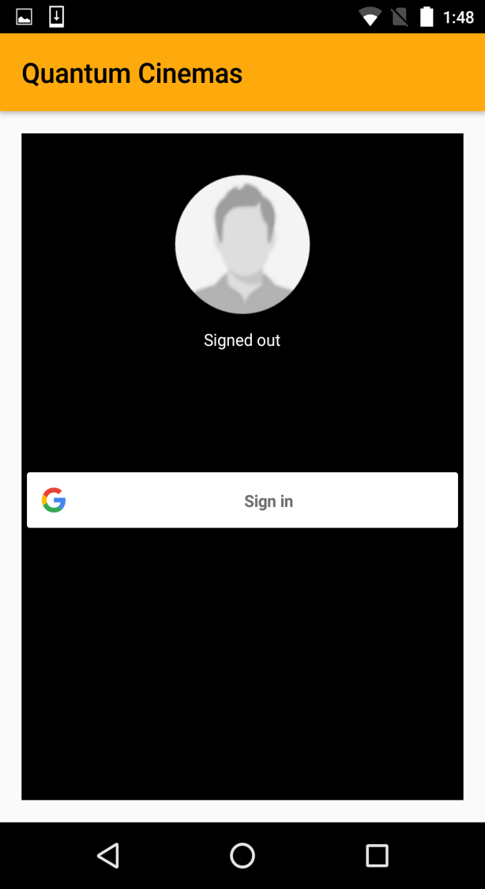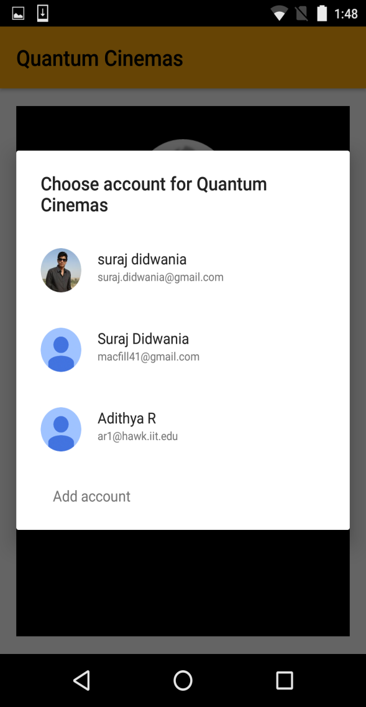

1. Coming Soon:

User can view the movies which are going to be released soon. The user will get option to watch trailer of movie

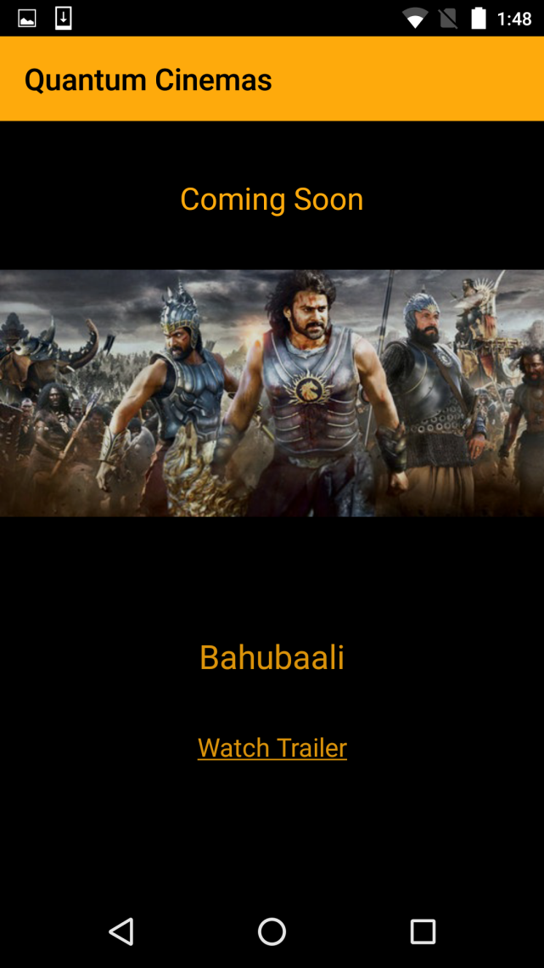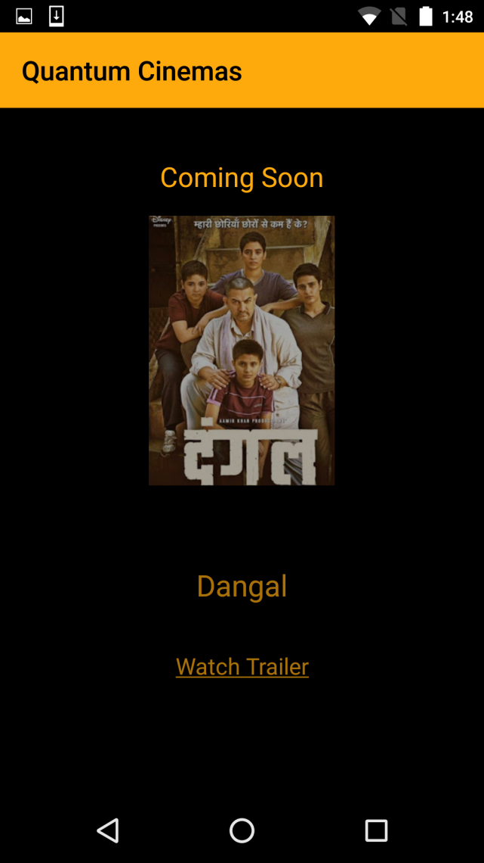

1. Reviews:

On clicking this link user will be directed to page where he can write review about the movie. User will get option to write review like a chat application where he can give any view or discuss about anything.

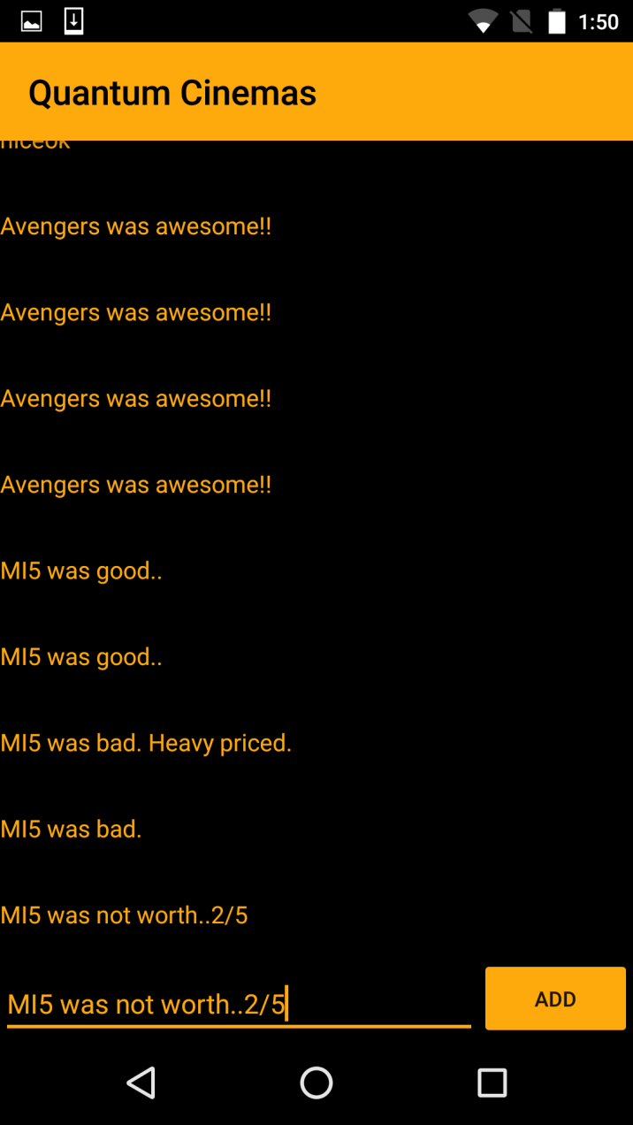

1. Video Gallery

On clicking this menu item. User can watch trailers of movie that are available in application. User can select movie for which he wants to view trailer from drop down menu

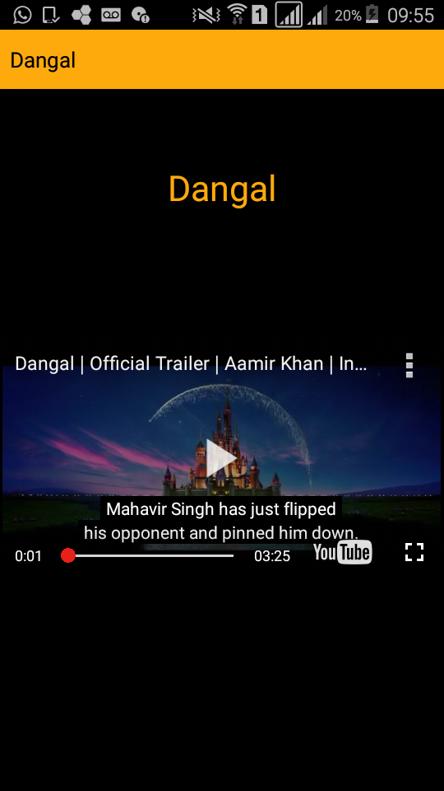

1. Logout: Application will be closed and user will be logged out of application